Anthony Sevarino

EET 2141

Fall ‘24

**Lab 3: Diode Applications – Diode Limiting and Clamping Circuits**

**Introduction:**

The objective of this lab is to analyze diodes, specifically their interactions and behaviors within diode limiting, and diode clamping circuits. A diode limiting circuit is responsible for limiting either the positive, negative, or entirety of an alternating voltage signal. In other words, this type of circuit will “clip” certain parts of the waveform. On the contrast, a diode clamping circuit aims to shift the entire voltage from a signal to a new, predetermined point. In essence, it will move the DC value up or down, therefore changing the average of the AC waveform. The oscilloscope will again be used in measurements for this lab, so more advanced knowledge of fundamentals regarding the equipment will be reinforced. The differences between input and output waveforms will be the center of the analysis for this lab, and prove the functions of both the circuits being observed.

**Bench Parts and Equipment List:**

# *Components*

|  |  |  |  |
| --- | --- | --- | --- |
| • | 1kΩ, 33kΩ Resistor | • | 4001N Diode (2x) |
| • | 1µF Capacitor |  |  |

# *Equipment*

|  |  |  |  |
| --- | --- | --- | --- |
| • | Programmable DMM | • | ELENCO Trainer Board |
| • | Triple Power Supply | • | Windows Machine w/ Multisim |
| • | DS1102E Digital Oscilloscope and Probes | • | Function Generator |

**Discussion:**

# *Part 1 – Diode Limiting Circuits*

The first step in this lab will be to construct our first diode limiting circuit in Multisim to observe the theoretical behavior of the circuit without varying resistor values or inconsequential smaller internal resistances of certain pieces of equipment, such as a DMM, Function Generator, or Triple Power Supply. Below is the constructed circuit for part 1 of the lab:

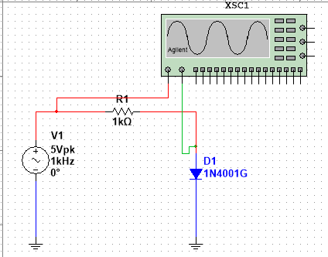

Figure - Part 1 Diode Limiting Multisim Circuit

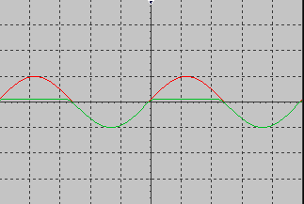

Figure - Part 1 Diode Limiting Multisim Circuit Waveform

Here, measurements were taken with the Agilent Oscilloscope with the anode of which connected to the input source, and the cathode connected to the anode of the diode. The first of these aforementioned measurements taken is the peak input voltage, which is 5v. This can be proven using the following formula:

Note that the voltage of the output waveform is cut off, or “clipped” above around 600mv. This co-aligns with our theory that a diode limiting circuit serves as a “clipping” circuit for output voltage. This is very close to the voltage bias value of a diode (0.7v).

Figure - Circuit 1 Constructed on Bench

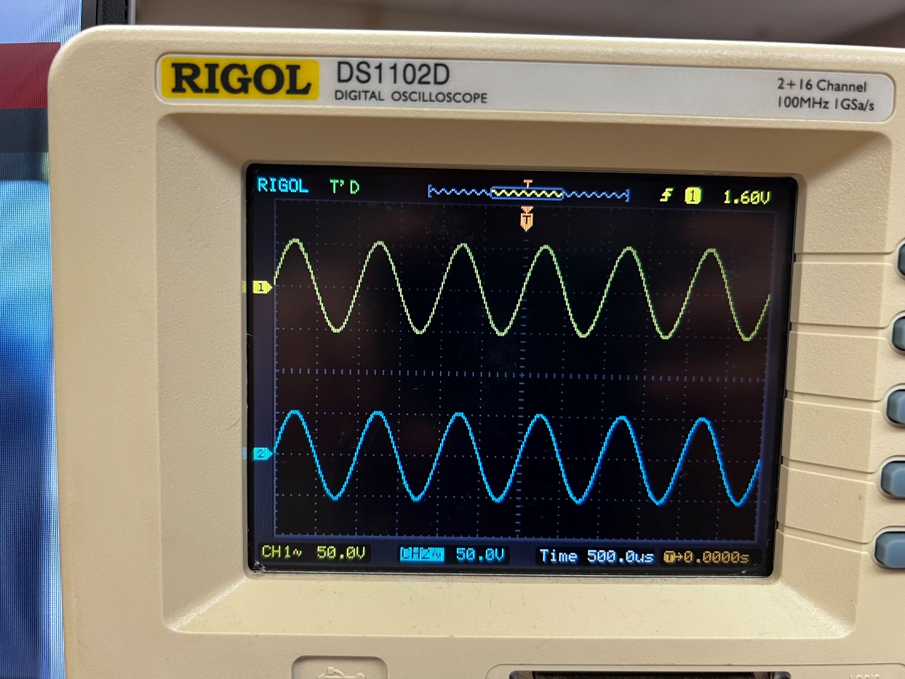

Figure - Circuit 1 Bench Waveform

Now, build the second circuit offered in the lab manual for comparisons’ sake, first as a simulation:

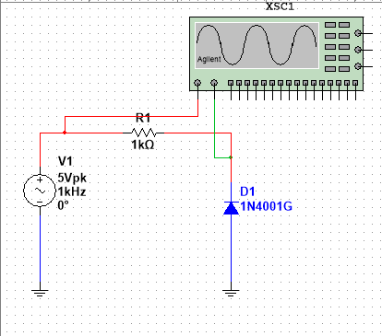

Figure - Part 1 Diode Limiting Multisim Circuit 2

Note that the diode is now in reverse position compared to the last circuit. The negative polarity end of the diode is denoted by the horizontal bar that is tangent to the triangle. In this circuit, the negative of the diode is facing the flow of current. This end of the diode will not allow current to flow through it as it is an n type material as part of the pn junction of a diode. Recall that an n type material has little room to hold electrons.

When a diode is facing against the flow of current, this is known as *reverse bias*. Observe the resulting waveform:

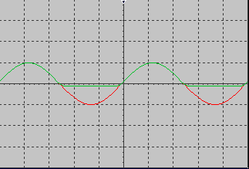

Figure - Part 1 Diode Limiting Multisim Circuit 2 Waveform

Similarly to the previous circuit, part of the output voltage is being clipped, namely, that above around -600mV is remaining. Thus we can derive that, in a *reverse bias*, clipping circuit, only the negative points of the alternating source are clipped, and the positive makes it through. Meanwhile in the *Forward Bias* circuit (**Figure 1**), the positive portion of the output signal is clipped, indicating that only the positive portion of the alternating signal is clipped by the resistor and the diode.

Now, add a second diode to the circuit, so that now there are two diodes (one in forward and one in reverse bias), a 1kΩ resistor, and the same AC voltage source as before:

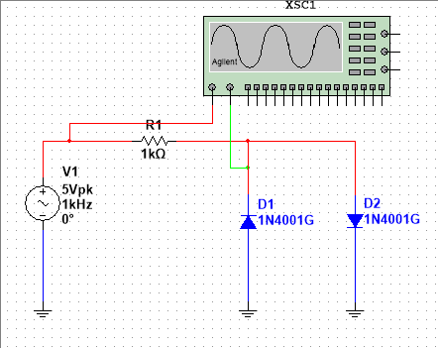

Figure - Part 1 Diode Limiting Multisim Circuit 3

The resulting waveform in the simulation is as follows:

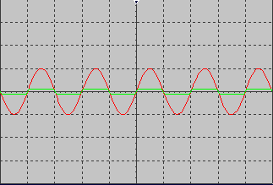

Figure - Part 1 Diode Limiting Multisim Circuit 3 Waveform

Here we can see that the output voltage is clipped both above and below around 600mV and -600mV, as there is both a diode in *Forward Bias* as well as *Reverse Bias*.

# *Part 2 – Diode Clamping Circuits*

As briefly discussed in the introduction of this lab report, the purpose of a diode clamping circuit is to shift the signal to some determined DC level, while maintaining the same signal shape. Common applications of this include television transmitters and receivers.

Below, an example of a clamping circuit is constructed in Multisim, using an AC voltage source, a capacitor, a diode, and a resistor (as per the specifications set by the lab manual):

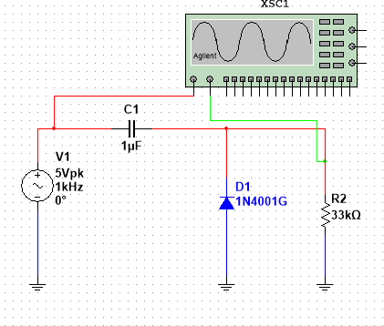

Figure - Part 2 Diode Clamping Multisim Circuit 1

Note that in this, and each of the previous Multisim circuits, the *Agilent Oscilloscope* digital device is used to measure the AC input and output signal. Below is the resulting waveform for this circuit:

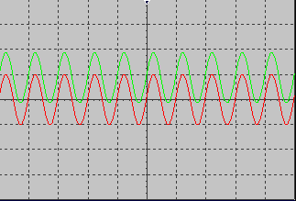

Figure - Part 2 Diode Clamping Multisim Circuit 1 Waveform

Note that this simulation version of the waveform confirms the theory that a diode clamping circuit maintains the shape of the signal while simply moving the DC level of it.

Next, the circuit is to be constructed on the bench so the real-world behavior of it can be observed and analyzed:

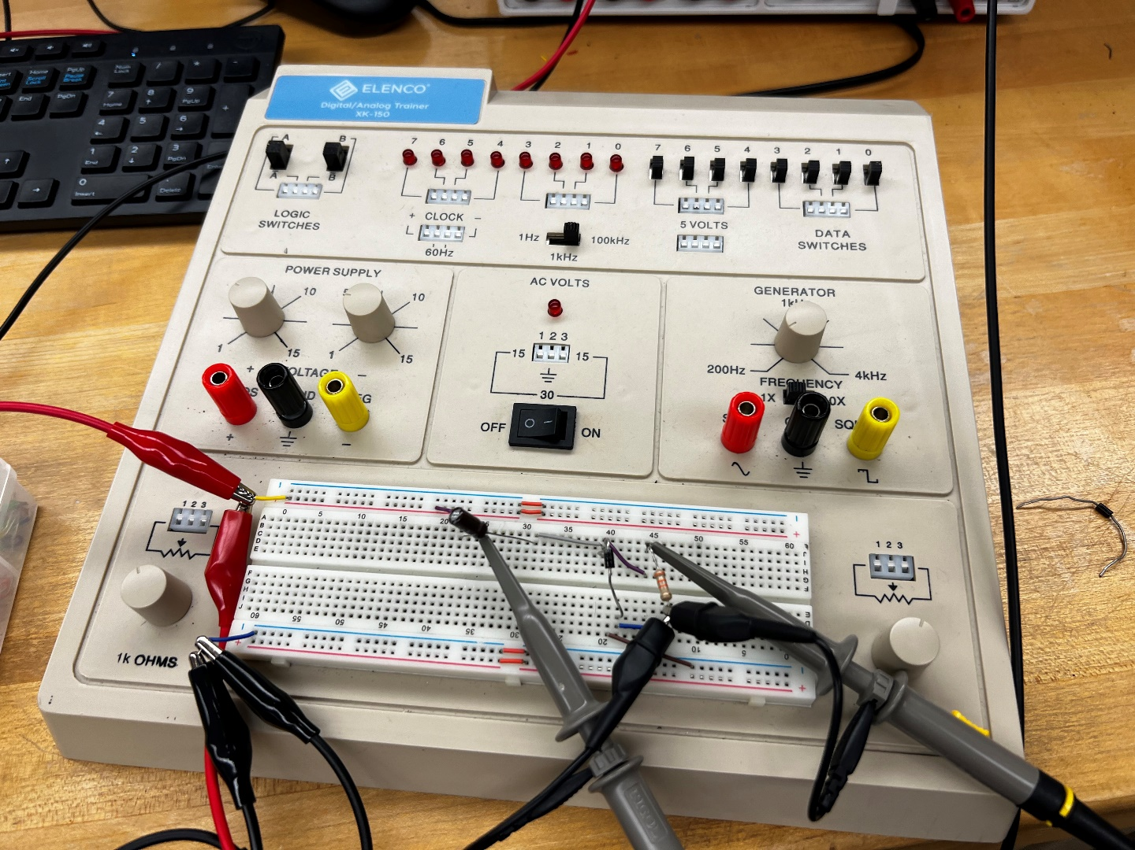

Figure - Circuit 4 Constructed on the Board

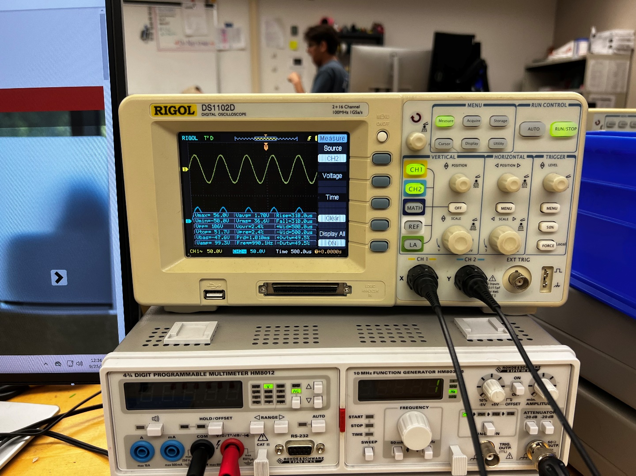

Figure - Circuit 4 Board Constructed Waveform

For continuity’s sake, the voltage across the capacitor, and the voltage across the resistor are measured both in the simulation as well as on the bench, the data of which can be found below in **Table 1**. A supporting graph is also included to visualize any discrepancies present in the data.

**Table 1 – Bench and Simulation Measurements of Voltage**

|  |  |  |
| --- | --- | --- |
|  | **Simulation**  **(v)** | **Bench**  **(v)** |
| **VC** | -4.398 | 4.16 |
| **VR** | 4.398 | 4.06 |

Figure - Graph Depicting Visualization of Data

The difference between the two sources (input and output), is that the input is the numerical inverse of the output (same signal but negative).

Finally, for certification purposes, below the instructor sign-off can be found. As a reminder, this signature is obtained by either the course instructor or a certified lab assistant to ensure proper results are being obtained.

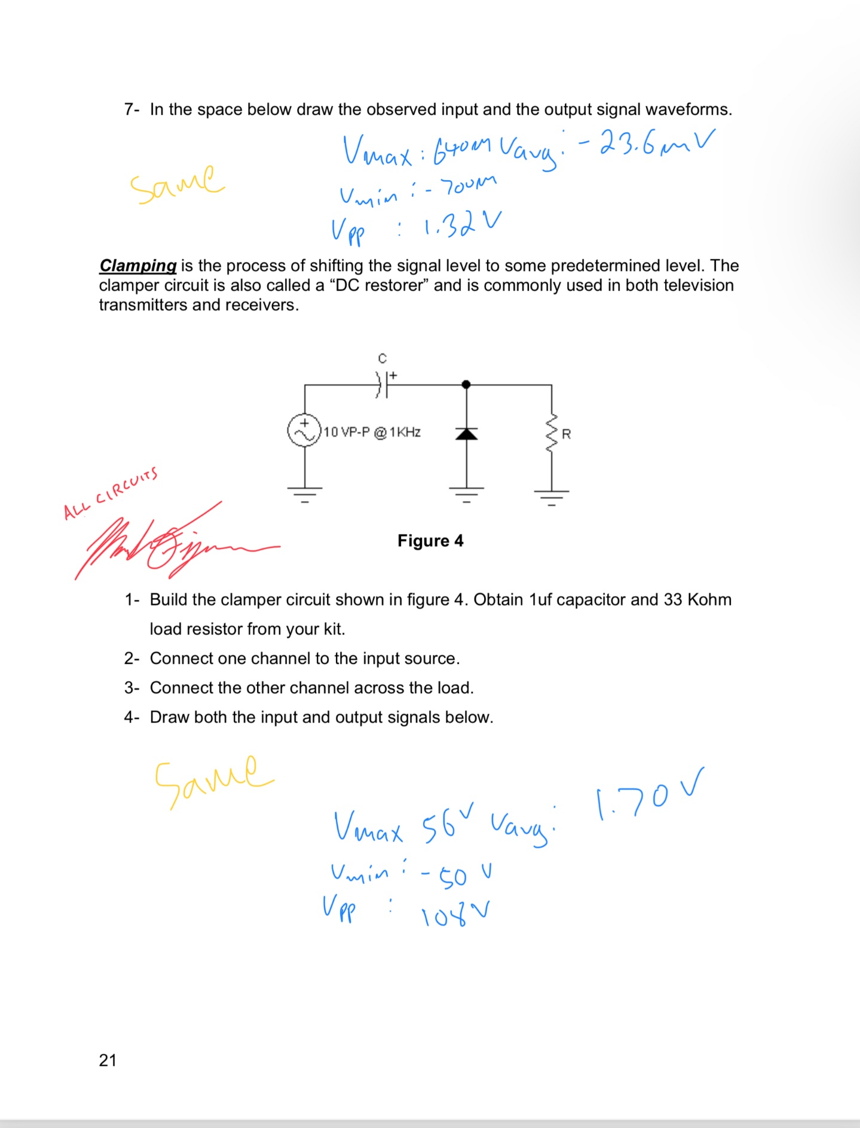

Figure - LA Approval Signature for All Circuits

**Conclusion:**

The objective of this lab is to obtain an understanding and visualization of the behavior and purposes of diodes in both a diode clipping circuit, and a diode clamping circuit. This objective was met successfully as is indicated in our matching data found in our comparison graphs at the end of the report. Here we can learn that a diode clipping circuit acts to clip certain parts of the alternative current (or voltage) signal above or below a certain point. Multiple diodes can be used to clip both the positive and the negative portion of such a signal. We also learn that a diode clamping signal maintains the shape and characteristics of the input AC signal, but moves the DC level (sinusoidal midline) up or down. If this lab were to be conducted again, it would be pertinent to include additional circuits, more components in those circuits, and potentially begin to look into other sorts of diode based circuits such as amplifier circuits, and circuits with different types of diodes, such as Zener and Tunnel diodes.